 | 1 | 2 | 3 | 4 | 5 | 6
1 | 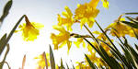 | vale | gay |  | wealth | lake
2 | continuous | bay |  | tossing | glee
3 | margin | 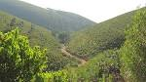 | wander |  | 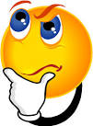 | Milky Way
4 |  | cloud | 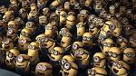 | sprightly | breeze
5 | jocund | 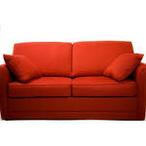 | company | couch |  | lake
6 |  | o’er | vacant | 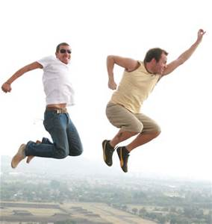 | gaze | 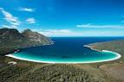

Roll the dice twice to select a square.
Write a sentence in your book using the word/image to show you understand its meaning.
Challenge: Can you think of a synonym (word similar in meaning) for the square you’ve landed on?

